Online learning platform

Entities & Attributes
Students(student_id, name)
Instructor(instructor_id, name)
Course(course_id, title, instructor_id)
Module(module_id, course_id, title)
Lesson(lesson_id, module_id, title)
Enrollment(student_id, course_id)
Progress(student_id, lesson_id, status)
Review(review_id, student_id, course_id, rating, comment)
Tag(tag_id, tag_name)
CourseTag(course_id, tag_id)

Relationships
Student ↔ Course → M:N (via Enrollment)
Course → Module → 1:N
Module → Lesson → 1:N
Student ↔ Lesson → M:N (via Progress)
Course ↔ Tag → M:N (via CourseTag)
Course → Instructor → 1:N
Student → Review → Course → 1:N
Normalization
1NF:
- No repeating attributes
- Tags separated
2NF:
- Composite keys in Enrollment & Progress
- No partial dependency
3NF:
- No transitive dependency
Example:
- Instructor stored separately
ER diagram
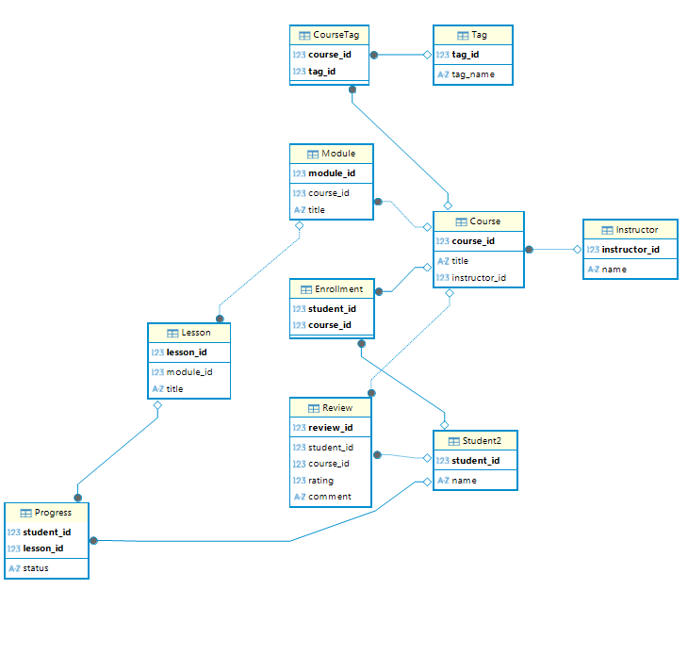
Enrollment:
Primary Key (student_id, course_id)

Progress:
Primary Key (student_id, lesson_id)

CourseTag:
Primary Key (course_id, tag_id)

